Sprint: 4

From: 05/20/2024 – 05/31/2024

# Team: ERA: Emergency Response Assist

|  |  |  |
| --- | --- | --- |
| **Team Member** | **Tickets** | **Points** |
| Jatin Madan | 3 | 12 |
| Vaishnavi Sunil Desai | 3 | 12 |
| Isha Ghiria | 3 | 12 |
| Sharvesh Patki | 2 | 12 |

# Sprint Overview:

|  |  |  |  |
| --- | --- | --- | --- |
| **Planned** | | **Completed** | |
| **Items** | **Points** | **Items** | **Points** |
| 11 | 48 | 11 | 48 |

# 

# Sprint Retrospective:

* What have you done during this sprint?
  + Jatin Madan
    - Jatin worked on materializing the UI for the ERA Administrator Dashboard to make it look modern and appealing for users.

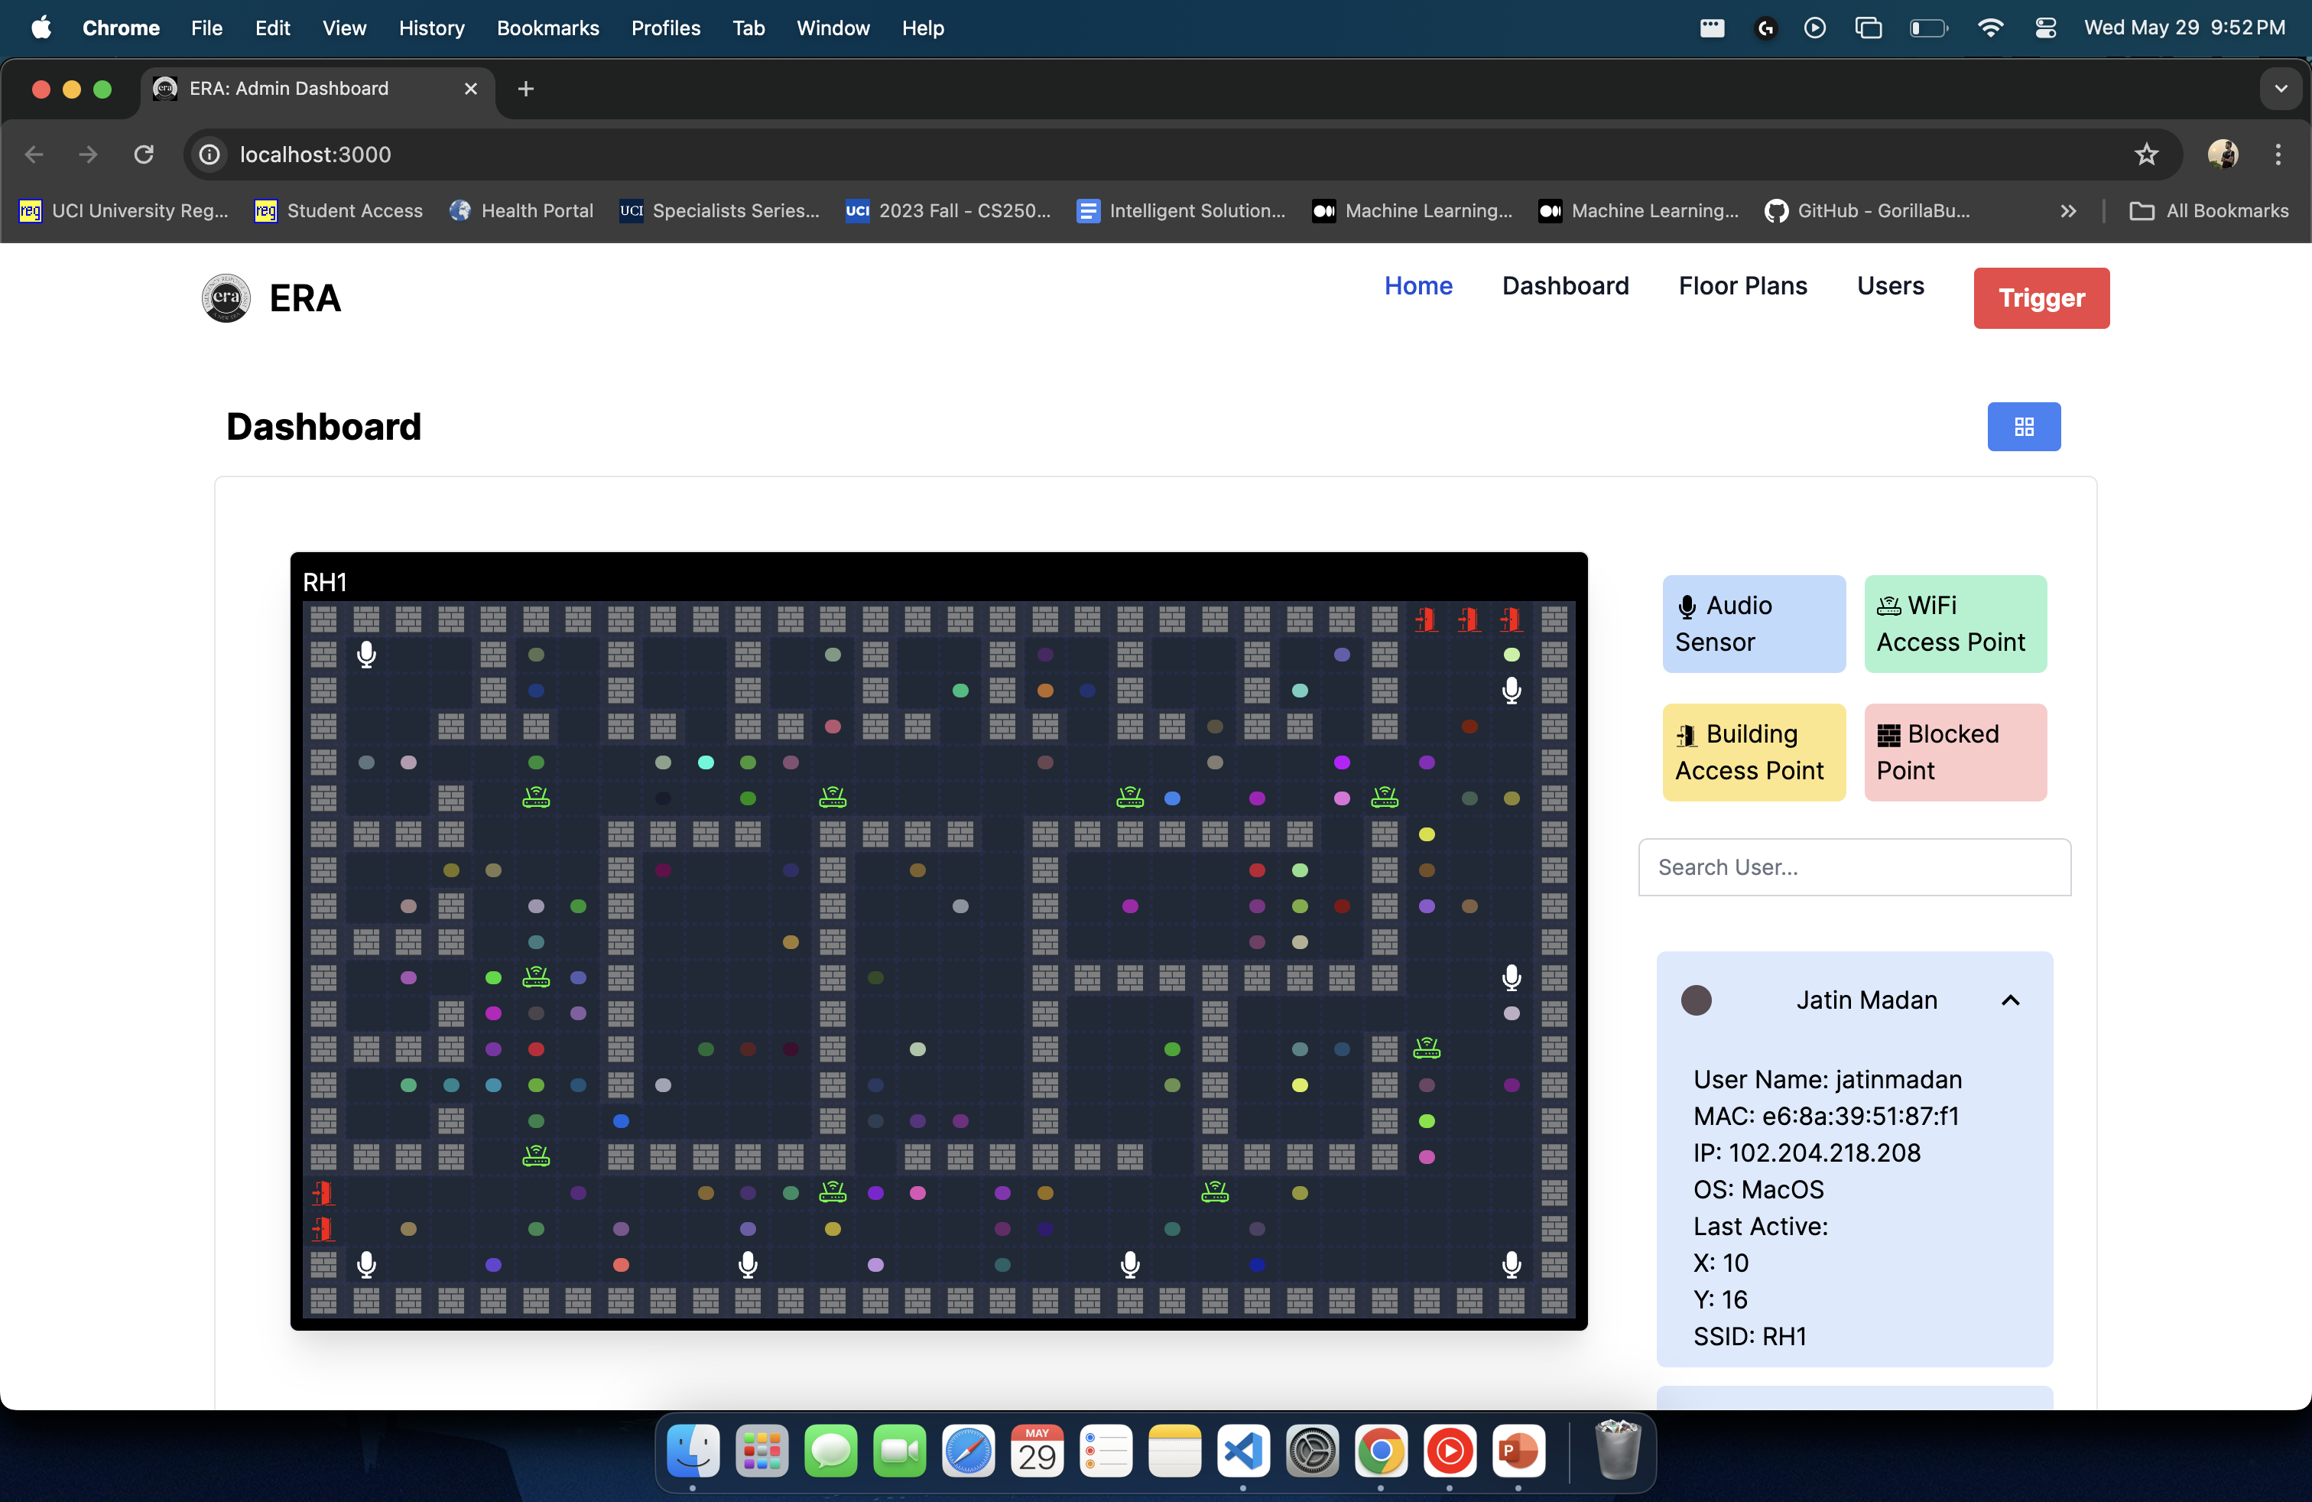

* + - Jatin also worked on integrating the Gunshot Machine Learning API with the Main ERA Server to include capabilities to initiate Triggers on Successful Gunshot Detection.

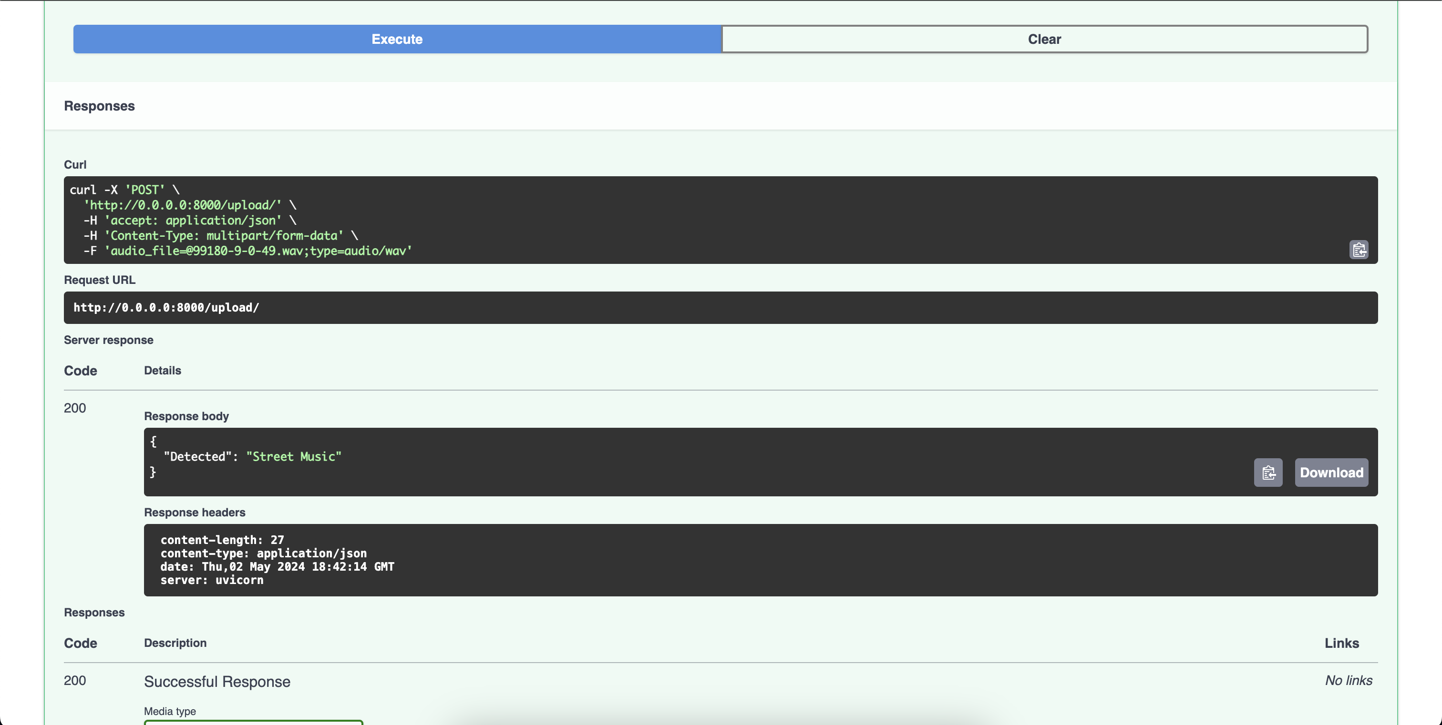

* + - Jatin also worked on improving the algorithm that would be able to predict and triangulate a user’s approximate location in a specified radius.
  + Isha Ghiria
    - Isha worked on updating the A* algorithm used for escape route planning to include multiple exit points during the search, and bifurcating the users between the different exit points to ensure order during the emergency

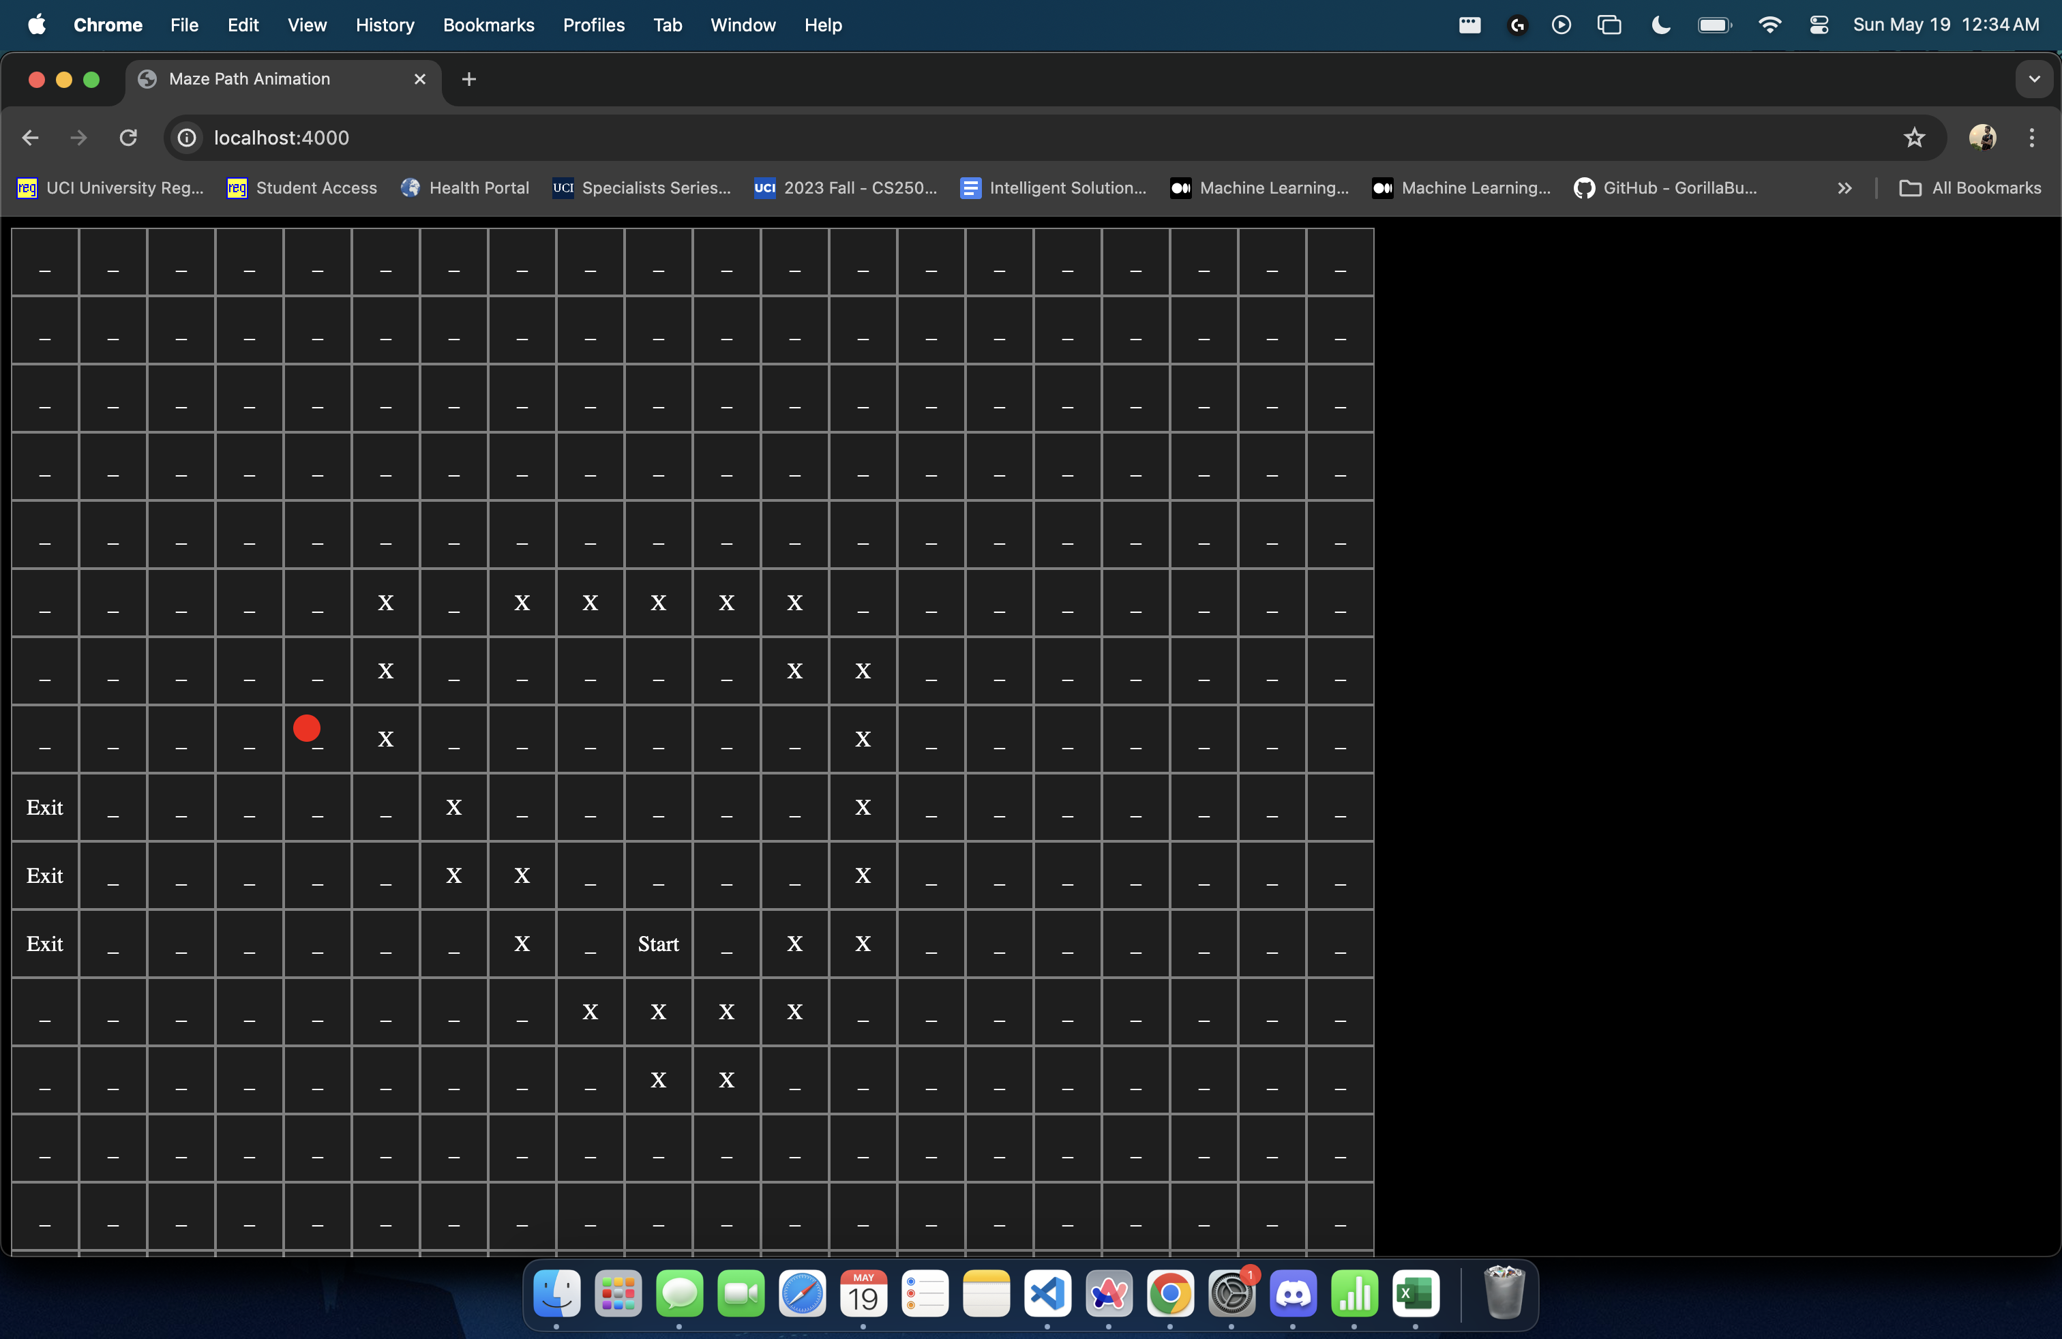

* + - Isha also worked on transforming the Floor Plan Data into Escape Route Algorithm Readable Format. This serves as the basis for the rest of the application to consume and analyze.

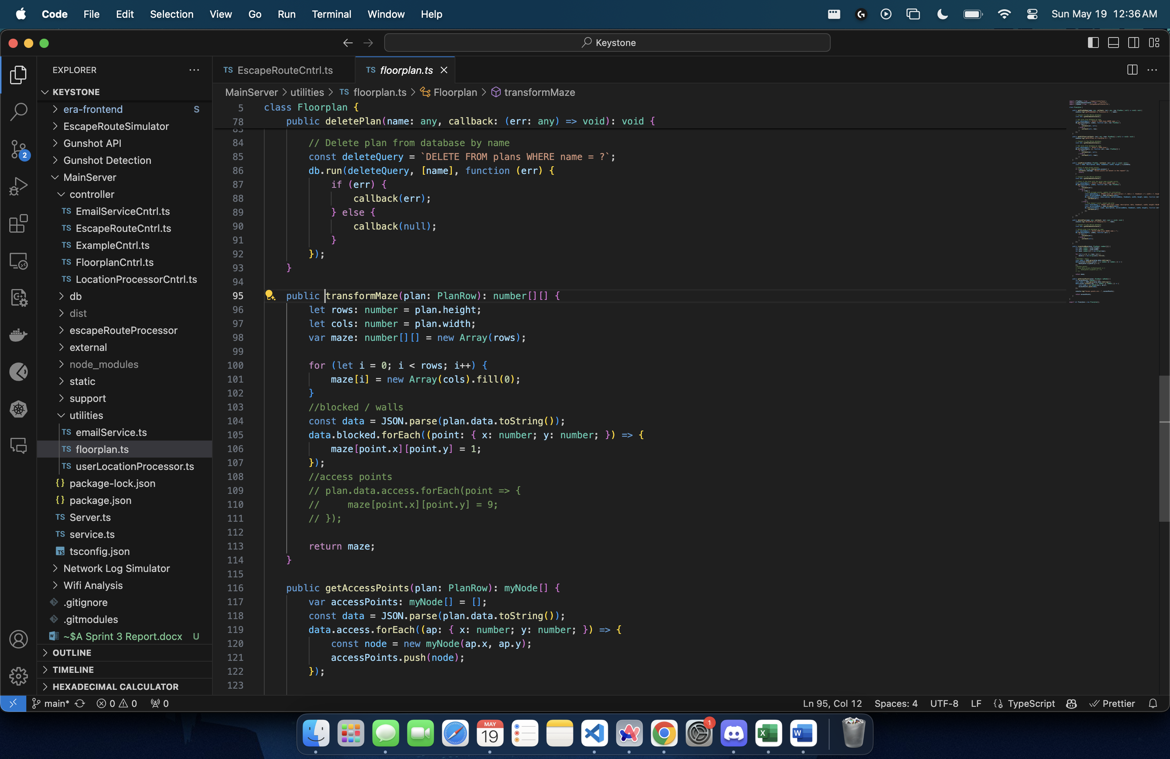

* + - Isha also worked on exposing an API on the Main ERA Server to plan the shortest route to the closest exit point for each user.

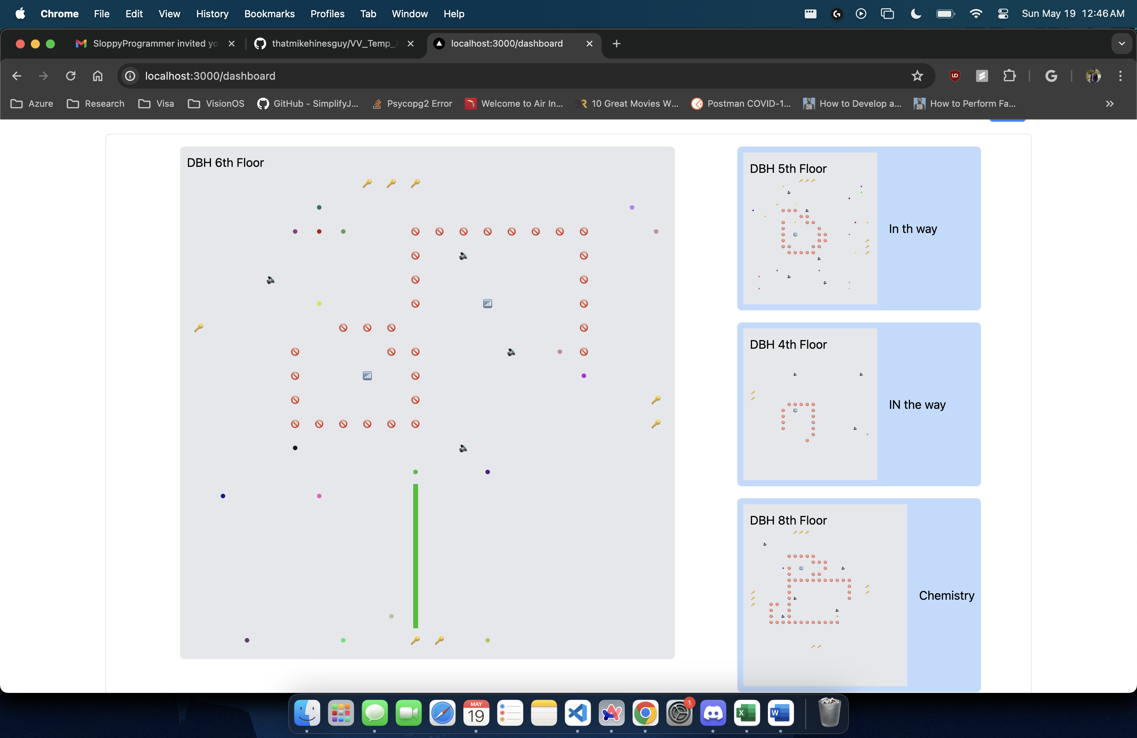

* + Vaishnavi Sunil Desai
    - Vaishnavi worked on materializing and updating the UI Component of Escape Route Plan

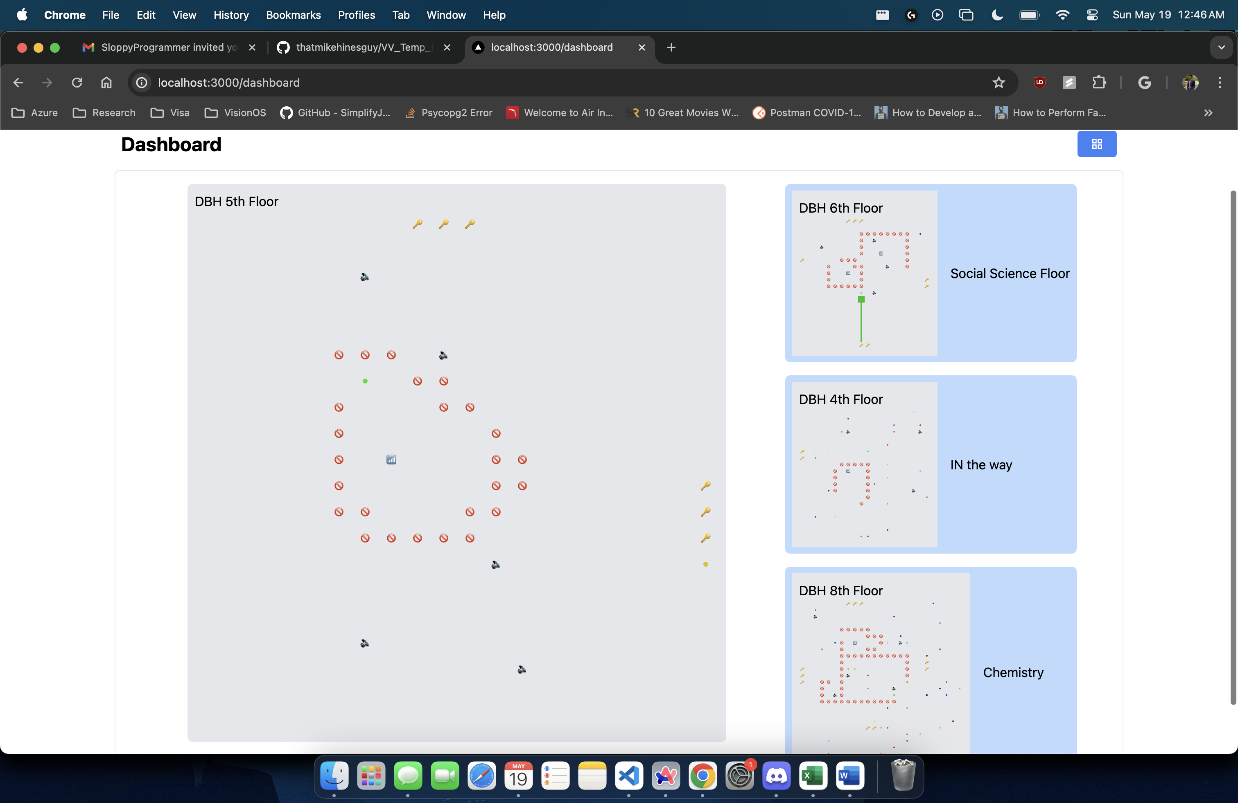

* + - Vaishnavi also worked on exposing an API on the Main ERA Server to poll data from Network Logs Simulator

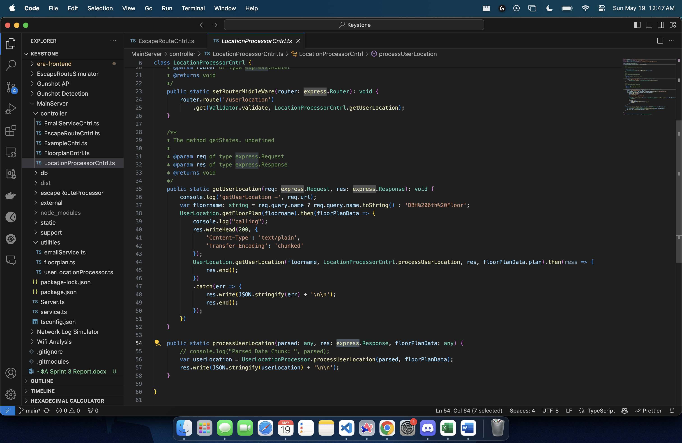

* + - Vaishnavi also worked on creating a triangulation algorithm using WIFI Access Point Logs

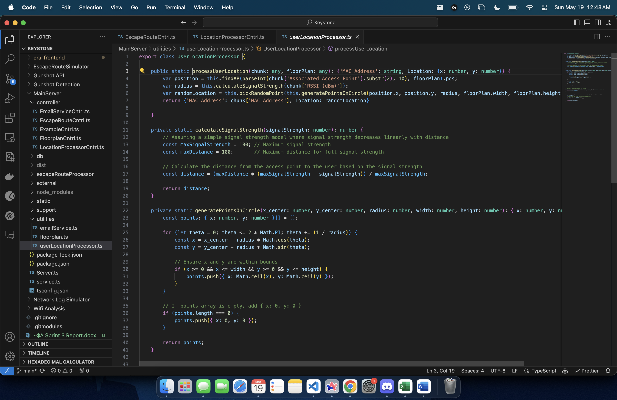

* + Sharvesh Patki
    - Sharvesh worked on materializing and updating the UI Component of ERA Administrator Dashboard

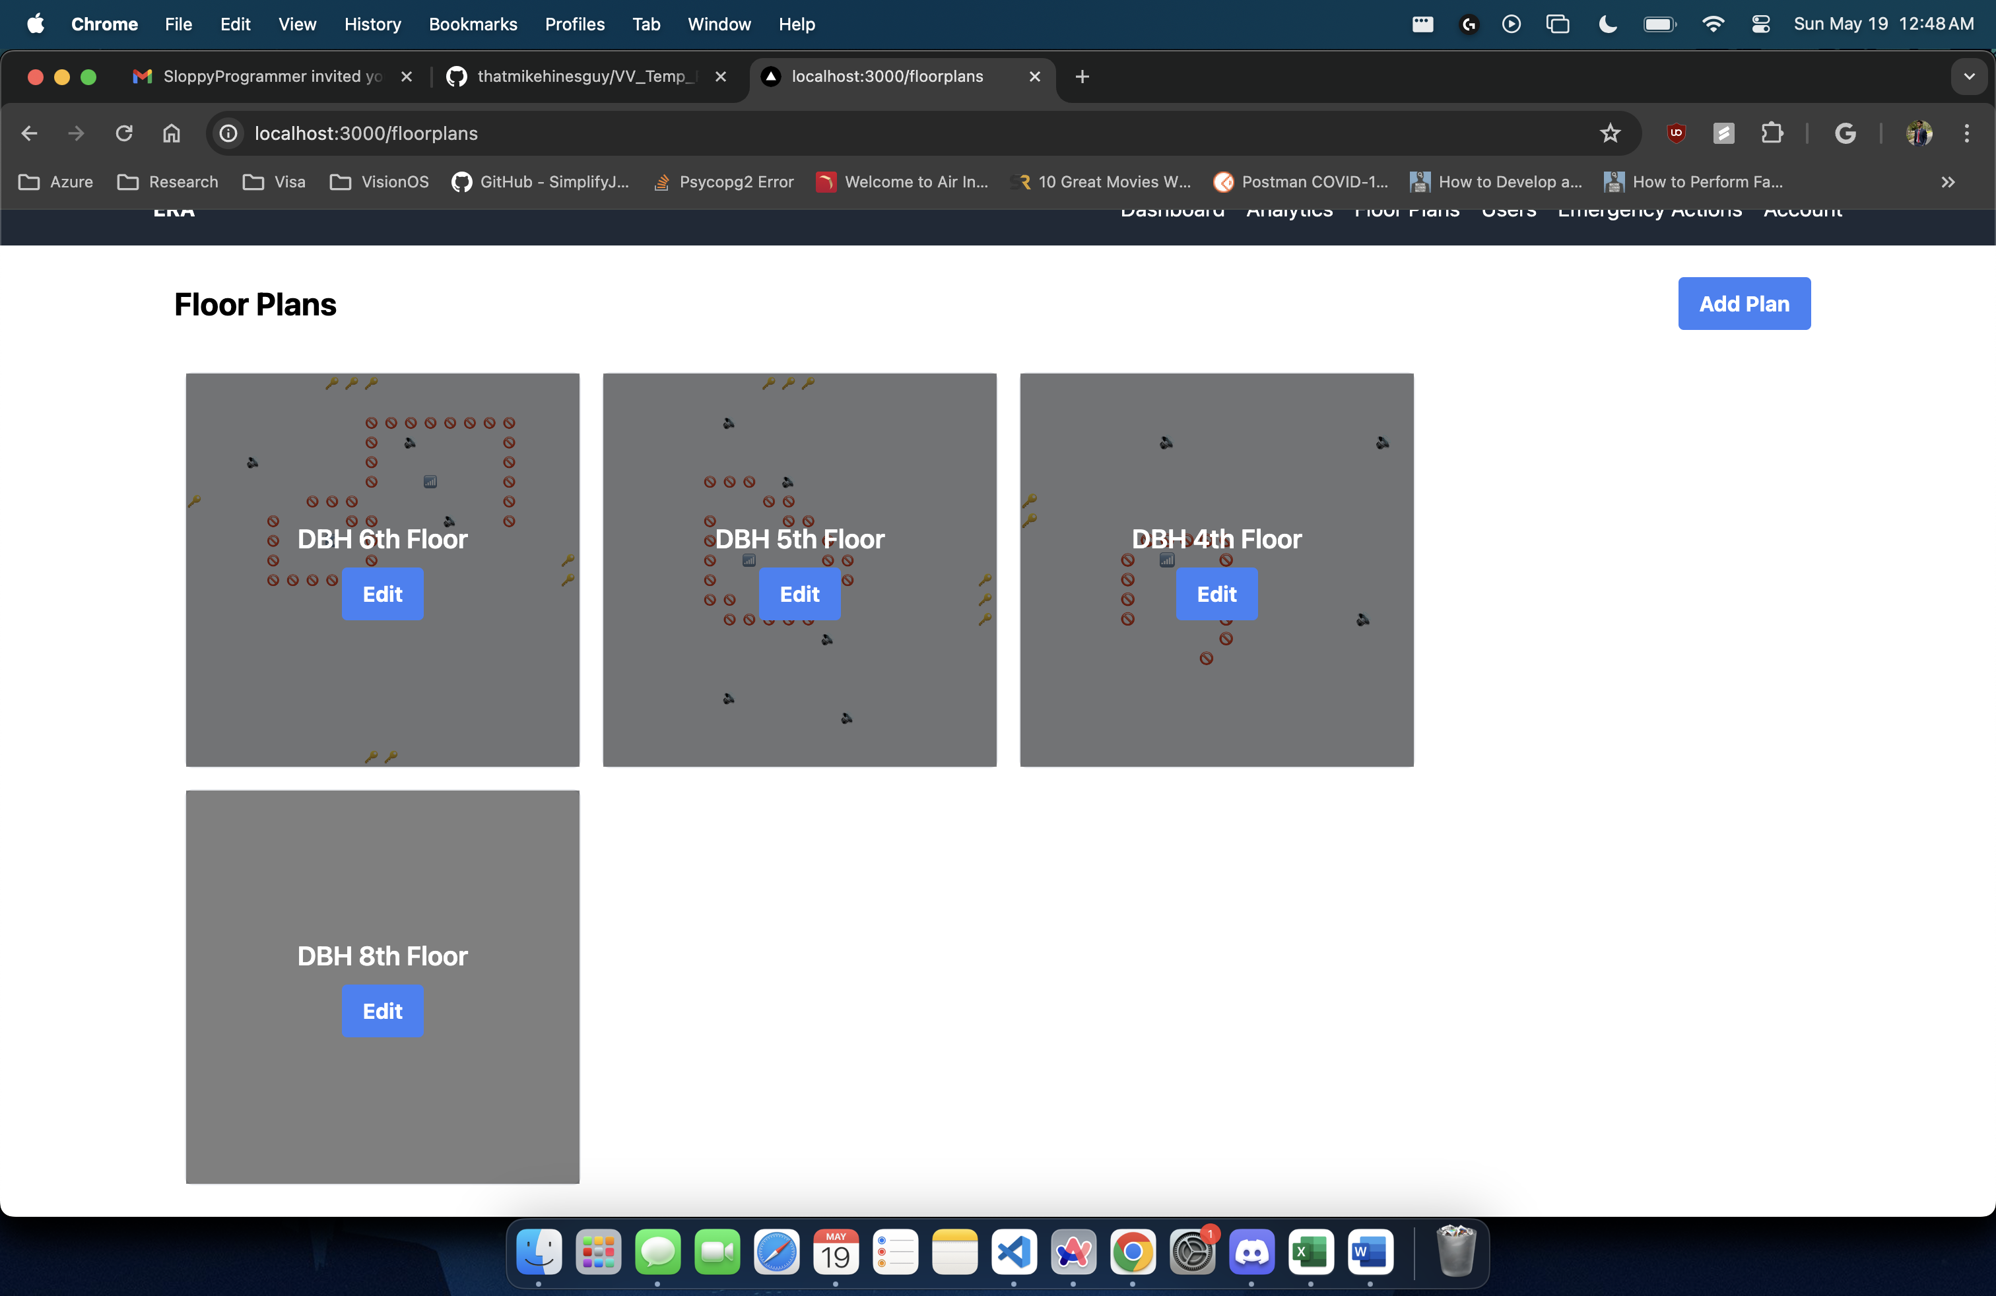

* + - Sharvesh also worked on materializing and updating the UI Component of ERA User Input Module

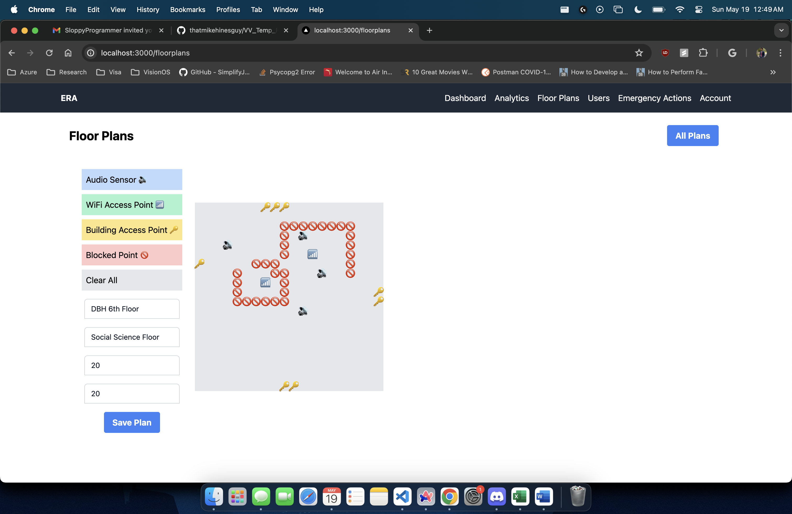

* What went well?
  + Despite, certain issues in task estimation, the team was successfully able to complete all the user stories for this sprint and make considerable progress on building the backbone of the ERA system.
  + The team demonstrated adaptability in responding to changes and adjusting plans as needed to address emerging issues or accommodate new requirements. This flexibility allowed them to maintain progress and keep the sprint on track.
  + The sprint provided opportunities for learning and growth, both individually and as a team. Challenges encountered during the sprint served as valuable learning experiences, helping the team identify areas for improvement and develop new skills.
  + The team applied best practices in agile development, such as conducting regular stand-up meetings, holding retrospectives, and using agile tools effectively. These practices contributed to the overall success of the sprint.
* What didn't go well?
  + Team
    - The Task estimation for User Story 8 (Materialize and Update the UI Component of ERA Administrator Dashboard) turned out to be inaccurate, as we went into development for the module, and we had to update our story points to include the updated effort.
* What could/should be improved during the next sprint?
  + We can divide our user stories into smaller atomic tasks, instead of grouping multiple tasks in one umbrella user story.
  + As we faced issue with one of the tasks in Task Estimation, we would be working on improving our estimates for the next sprint as they are crucial for better planning and execution. We would be involving the whole team during our sprint goal planning to have inputs on the task estimates.

# Sprint Backlog

|  |  |  |  |  |  |
| --- | --- | --- | --- | --- | --- |
| **ID** | **Type** | **Owner** | **Summary** | **Status** | **Estimate** |
| 1 | User Story | Jatin Madan | Calculate Triangulation Radius based on the Signal Strength | Completed | 4 |
| 2 | User Story | Vaishnavi Desai | Perform User Triangulation using WIFI Access Point Logs | Completed | 4 |
| 3 | User Story | Isha Ghiria | Expose API on the Main Server to retrieve shortest path for each user | Completed | 4 |
| 4 | User Story | Isha Ghiria | Update A* algorithm to take multiple end points | Completed | 4 |
| 5 | User Story | Isha Ghiria | Transform the Floor Plan Data into Escape Route Algorithm Readable Format | Completed | 4 |
| 6 | User Story | Vaishnavi Desai | Expose API on the Main Server to Poll data from Network Logs Simulator | Completed | 4 |
| 7 | User Story | Jatin Madan | Expose API on the Main Server to Poll data from Gunshot Detection API | Completed | 4 |
| 8 | User Story | Sharvesh Patki | Materialize and Update the UI Component of ERA Administrator Dashboard | Completed | 6 |
| 9 | User Story | Vaishnavi Desai | Materialize and Update the UI Component of Escape Route Plan | Completed | 4 |
| 10 | User Story | Sharvesh Patki | Materialize and Update the UI Component of User Input Module | Completed | 6 |
| 11 | User Story | Jatin Madan | Integrate Gunshot Detection API with the Main server to initiate Triggers | Completed | 4 |